**MAC -** <https://www.apple.com/mac/>

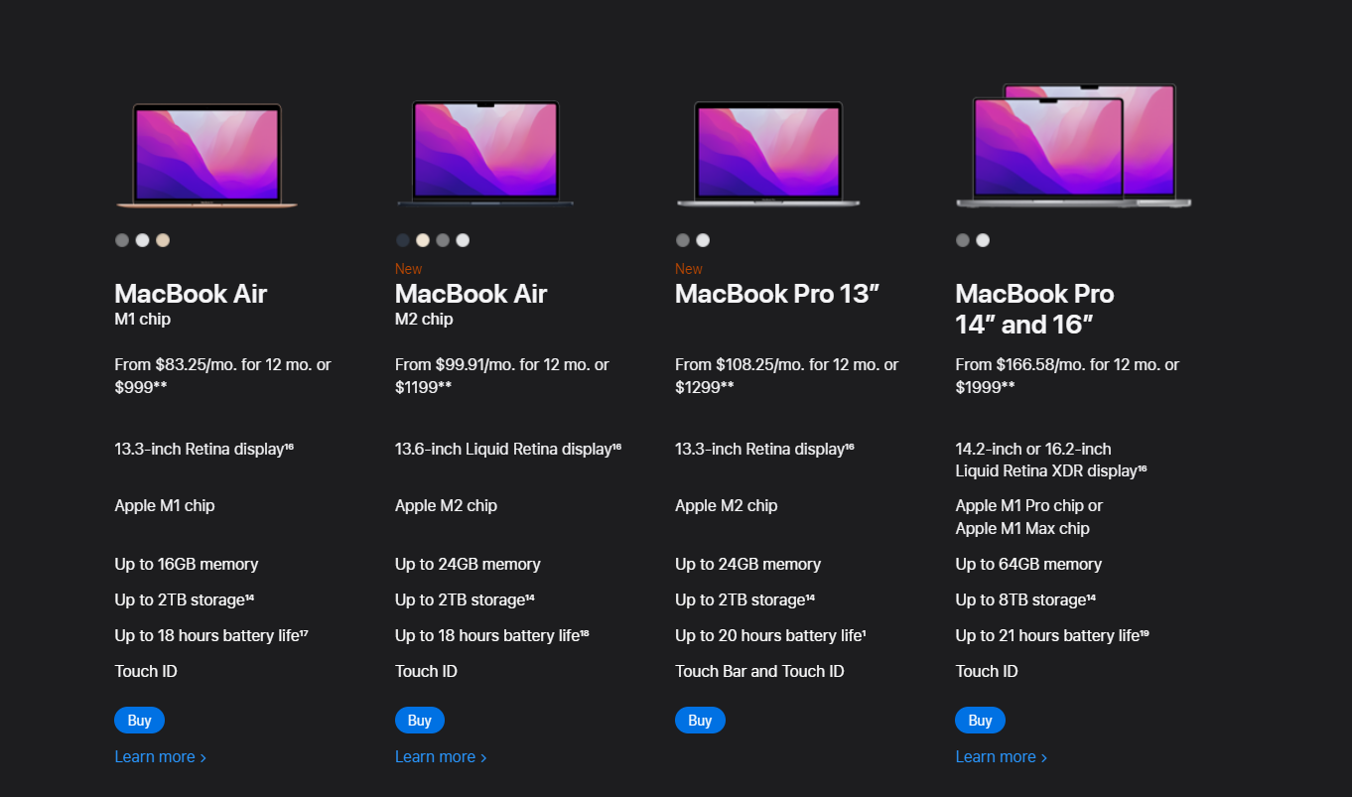

1. MacBook Air (m1 chip)
2. MacBook Air (m2 chip)
3. MacBook 13”
4. MacBook Pro 14” and 16”

**iPad -** <https://www.apple.com/ipad/>

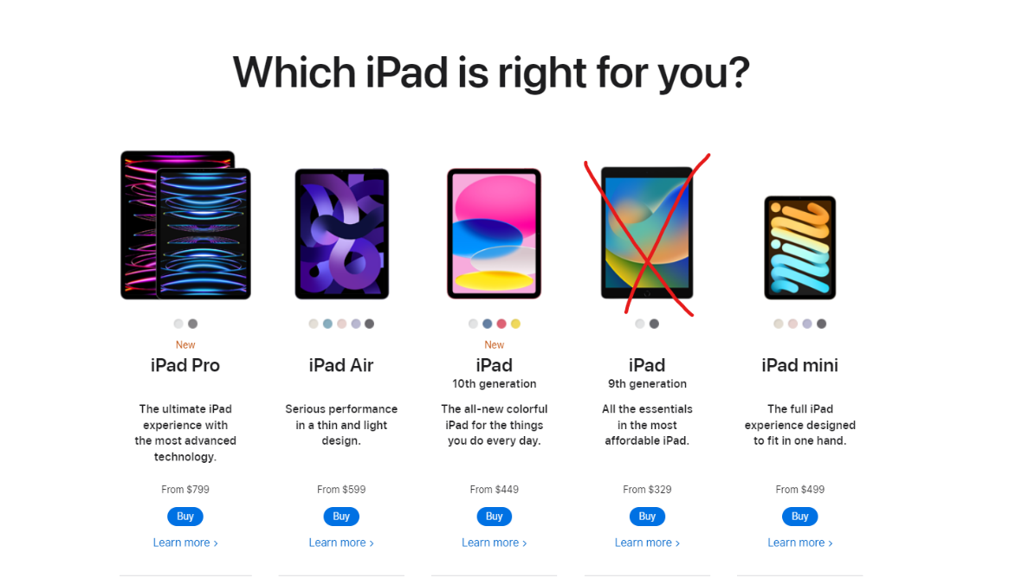

1. iPad Pro
2. iPad Air
3. iPad
4. iPad mini

**iPhone -** <https://www.apple.com/iphone/>

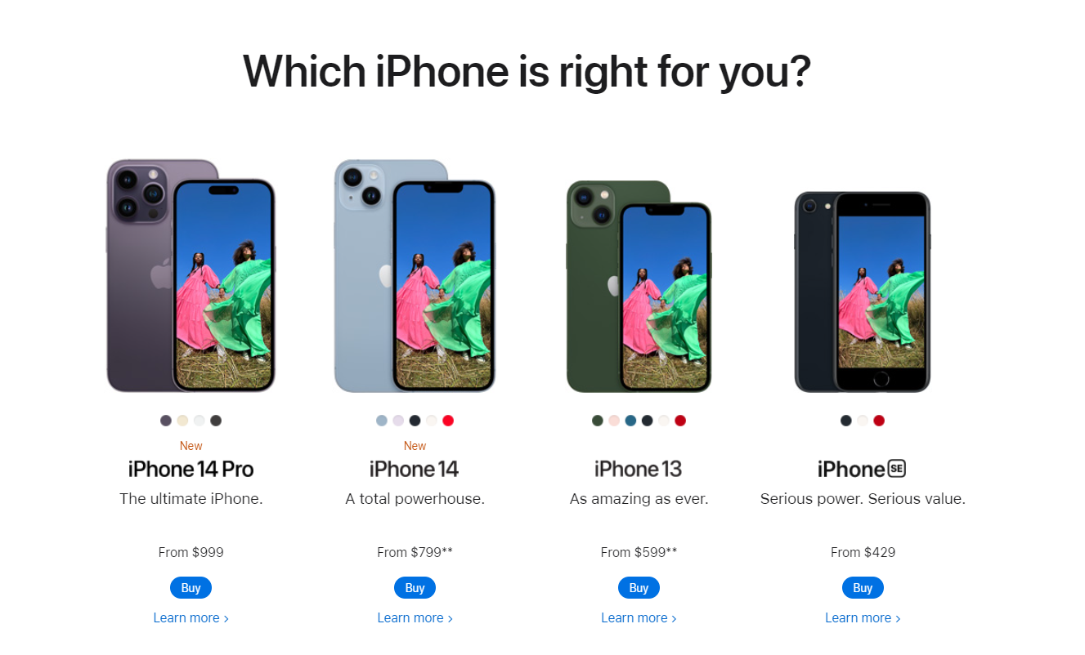

1. iPhone 14 Pro
2. iPhone 14
3. iPhone 13
4. iPhone SE

**Watch -** <https://www.apple.com/watch/>

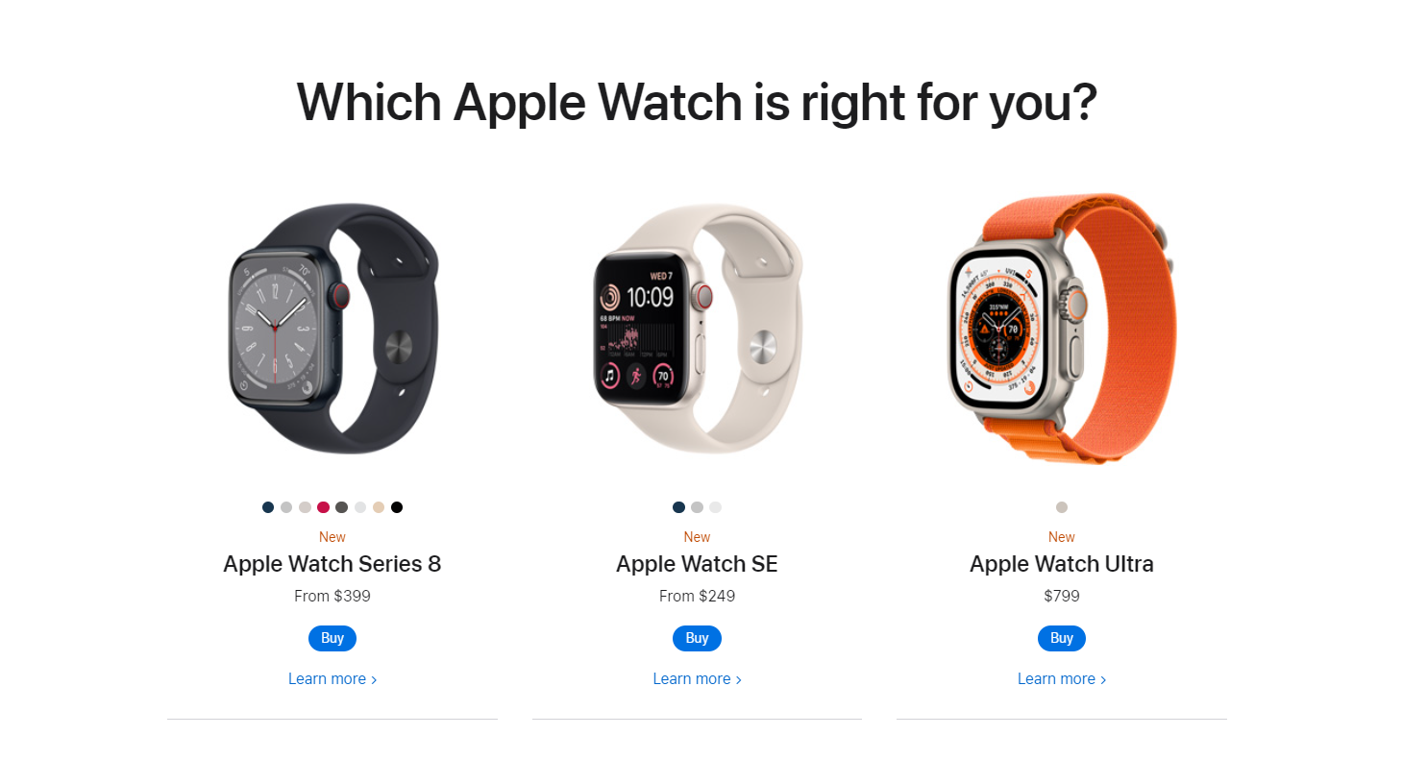

1. Apple Watch Series 8
2. Apples Watch SE
3. Apple Watch Ultra

**Fonts**

<link rel="preconnect" href="https://fonts.googleapis.com"><link rel="preconnect" href="https://fonts.gstatic.com" crossorigin><link href="https://fonts.googleapis.com/css2?family=Inter:wght@300;400&family=Space+Mono&display=swap" rel="stylesheet">